1. Connect BBB and PC via USB serial cable.

Refer <http://pillsfromtheweb.blogspot.com/2016/03/connect-beaglebone-black-and-mac-os-x.html>

Note: If using virtualbox to run Ubuntu Virtual machine: Please config as below

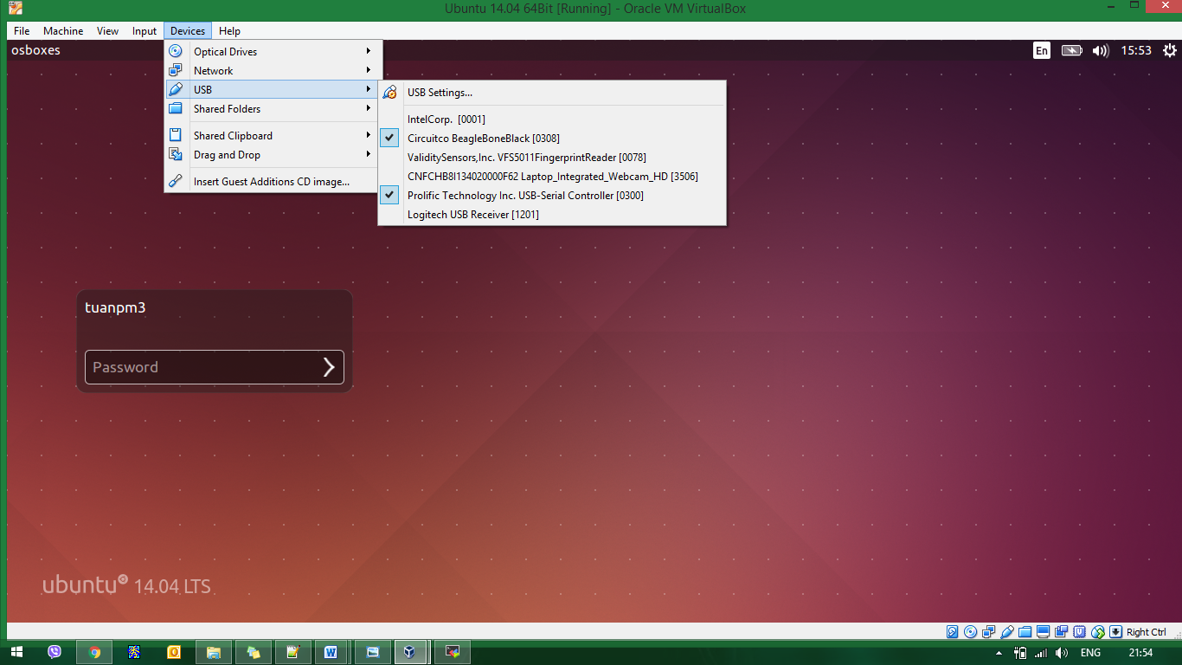

1. On Ubuntu

* Setting for minicom

|  |
| --- |
| $ sudo minicom –s |

setting as below (press A, B, C…G to setting):

+-----------------------------------------------------------------------+

| A - Serial Device : /dev/ ttyUSB0 (or ttyUSB1) |

| B - Lockfile Location : /var/lock |

| C - Callin Program : |

| D - Callout Program : |

| E - Bps/Par/Bits : 115200 8N1 |

| F - Hardware Flow Control : No |

| G - Software Flow Control : No |

| |

| Change which setting? |

+-----------------------------------------------------------------------+

press Enter → Save setup as dfl → Exit from Minicom

* Start minicom

|  |
| --- |
| $ sudo minicom  Welcome to minicom 2.7  OPTIONS: I18n  Compiled on Jan 1 2014, 17:13:19.  Port /dev/ttyUSB0, 15:51:24  Press CTRL-A Z for help on special keys |

***Note:*** if ttyUSB0 is locked. Do following

|  |
| --- |
| $ sudo minicom –S ttyUSB0 -o |